Task 4

While creating the game fruit ninja I came to some problems that where a bit tedious to work out, while starting the game I followed a tutorial to create the basis of the game, while doing this every step created I uploaded to Github.

* The first issue I ran into was the blade’s collider where it was just a simple syntax error that I didn’t notice about after a few minutes

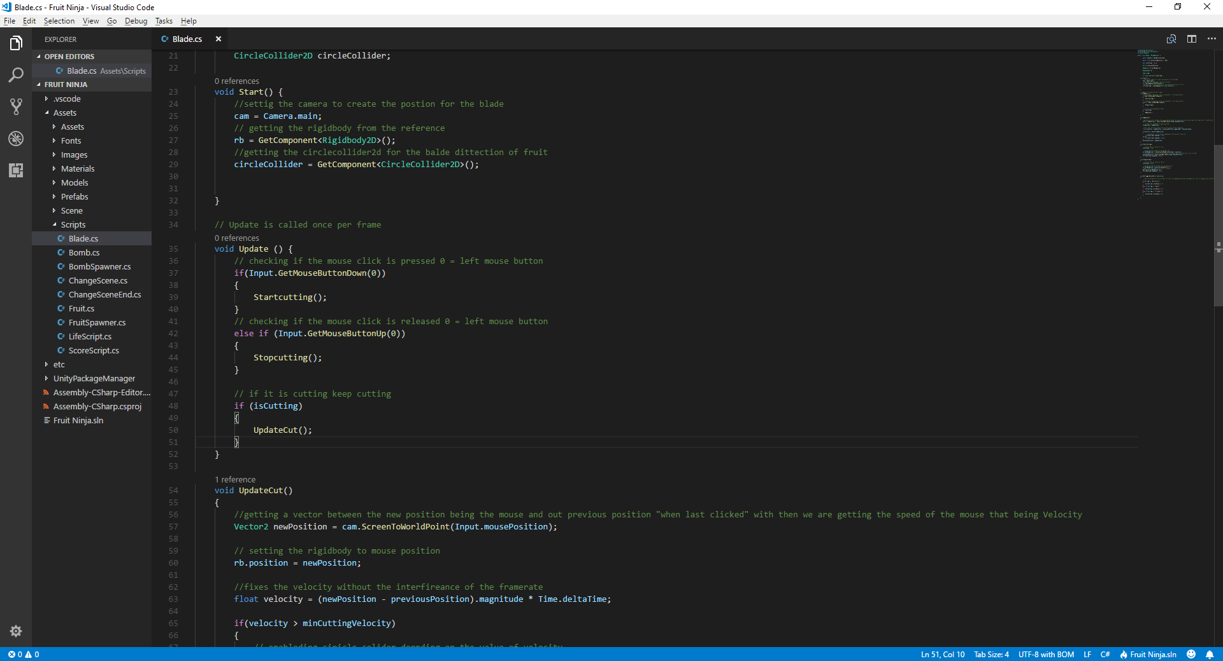the issue was that the input for the GetMouseButtonUp was written GetMouseButtonDown intend of the method Stopcutting() “ which stops the circle collider for the blade” was being left on.

* The second issue I ran into was the cutting of the fruit when the blade was hitting. Because I was using OntriggerEnter2D() an I needed to tick Circle Collider 2D Is Trigger function that will tell the fruit that it is a Triggering function.

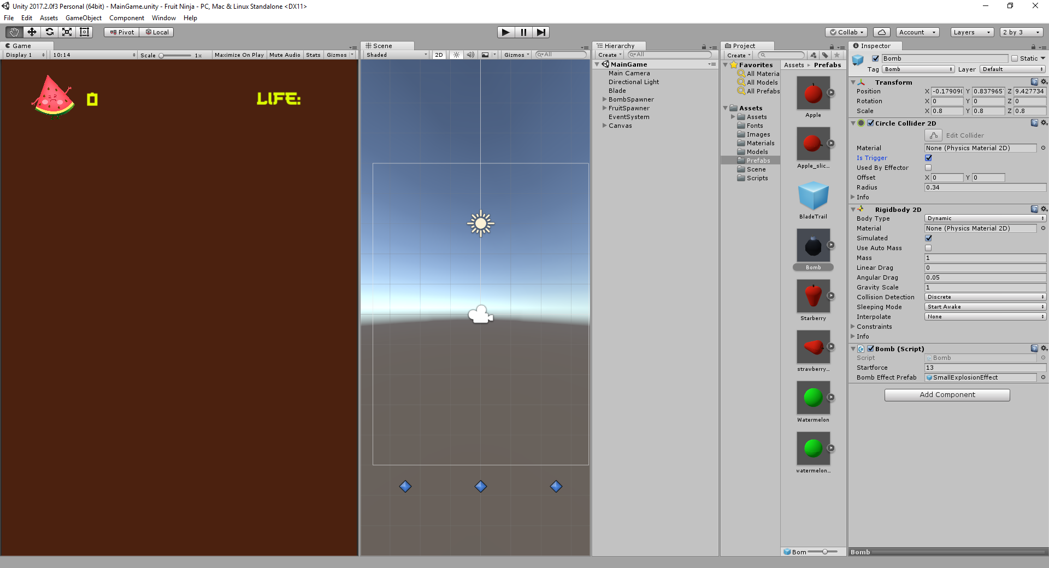

* The third issue I ran into was the slicing of the fruit when the blade first meets the circle collider, the issue was that the split was not cutting to the correct rotation of the fruit.

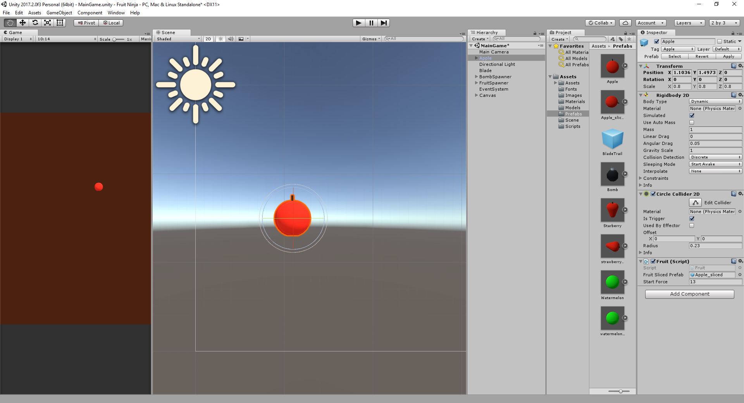the code was written correctly it was taking the position and the rotation of the fruit, but when it was being cut it was cutting in the wrong direction, so the fruit sliced prefab needed to be rotated to a different angle

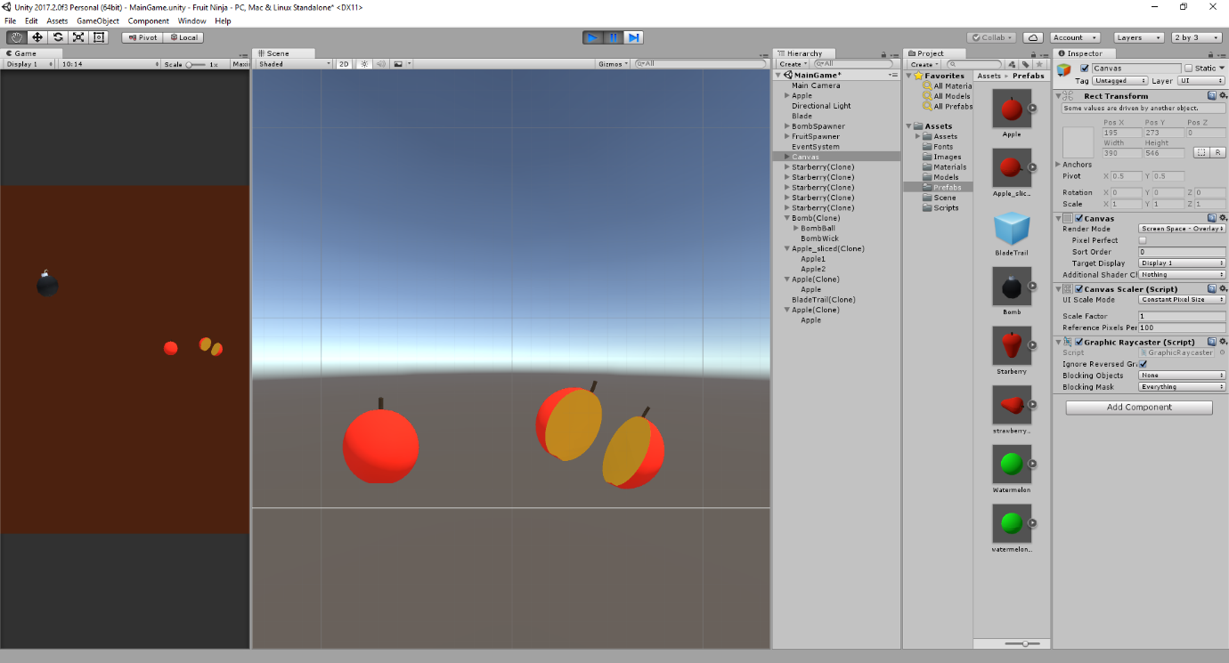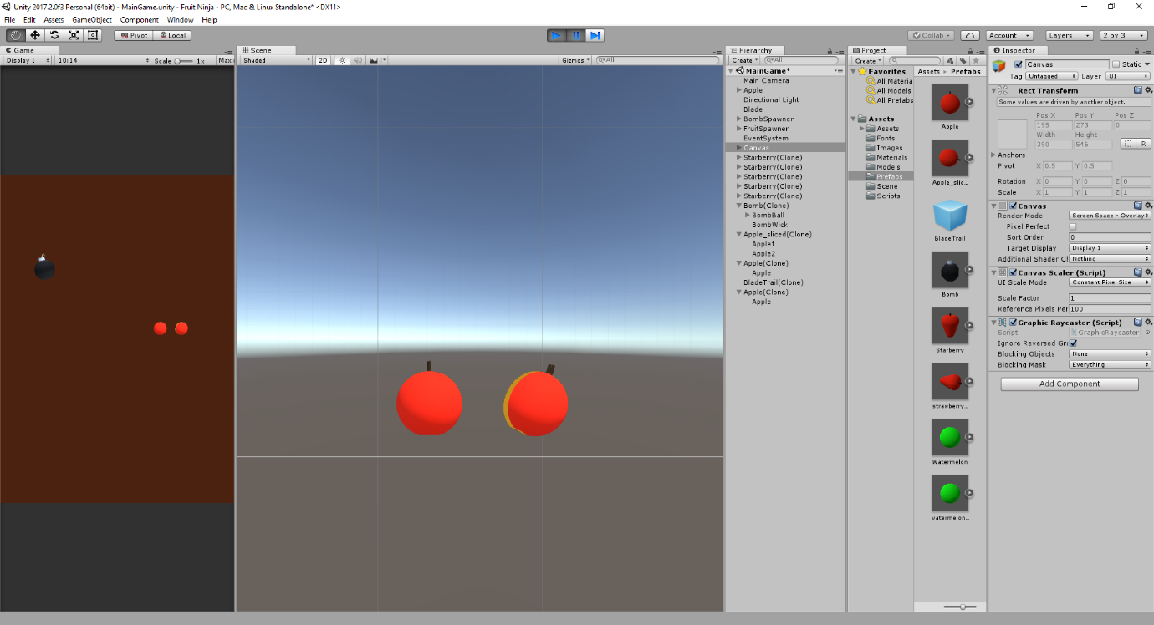the fruit’s rotation was not cutting correct due to its rotation

the fruit’s rotation was changed and the slicing cut was correct

* the forth issue was with the UI.

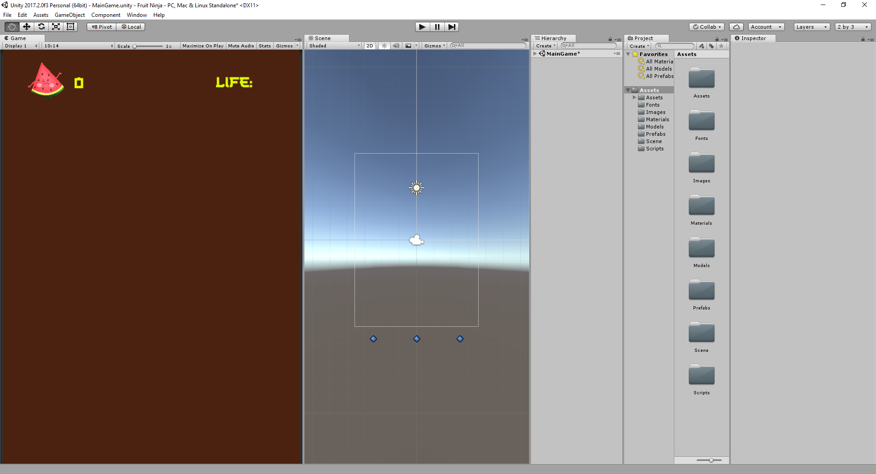

The issue was to set each individual fruit to update different values for each fruit, at first the score was when the fruit spawned spawn’s a fruit, if that fruit would have been hit by the blade it would at one point to the score, but because i wanted each fruit to have different values, I used the blade to register the corresponding fruit it hits by adding a tag to each fruit.

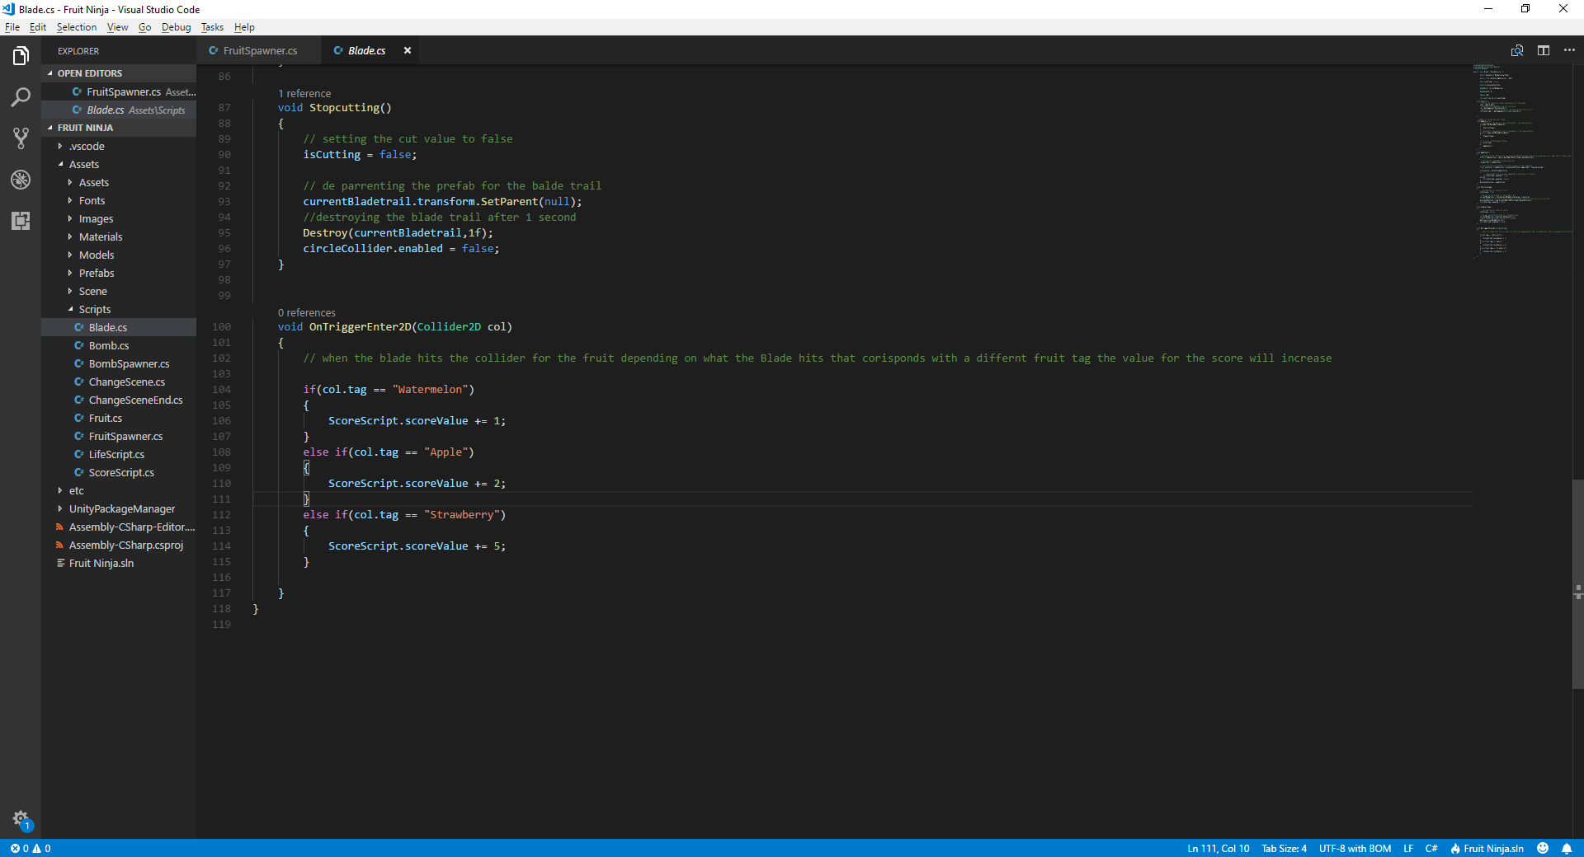

* The last issue was that when the game restarts the value for the scores was not resetting, but it was a quick fix because all I needed to do was to give the old values to the game back when the scene would change.

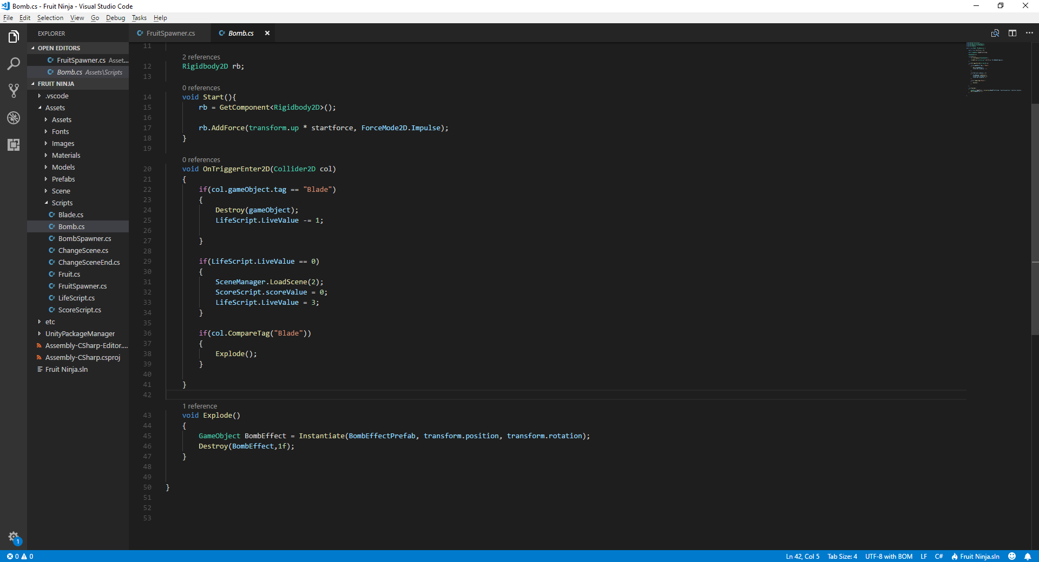

So when the scene changes the values will go back to default and the game can be replayed.